**Ideation Phase**

**Define the Problem Statements**

|  |  |
| --- | --- |
| Date | 28 June 2025 |
| Team ID | LTVIP2025TMID56240 |
| Project Name | **ShopSmart** |
| Maximum Marks | 2 Marks |

**Customer Problem Statement Template:**

**Example:**

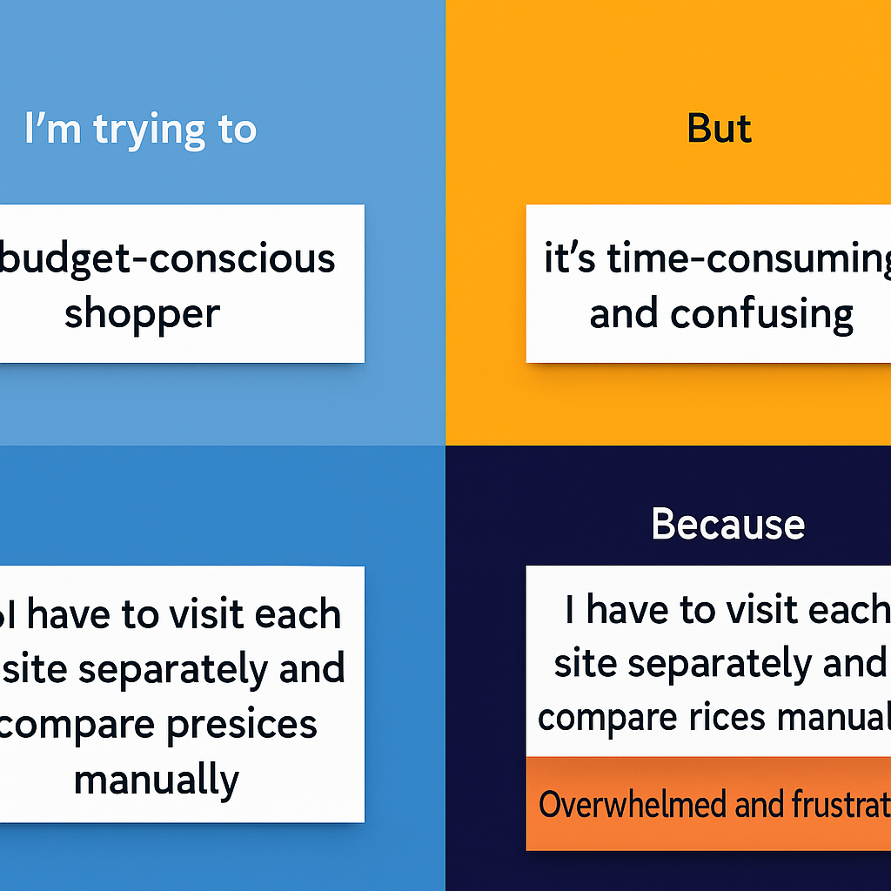

|  |  |  |  |  |  |
| --- | --- | --- | --- | --- | --- |
| **Problem Statement (PS)** | **I am (Customer)** | **I’m trying to** | **But** | **Because** | **Which makes me feel** |
| PS-1 | a budget-conscious shopper | find quality products at the best prices across platforms | it’s difficult to compare prices and offers from multiple websites. | e-commerce platforms don’t always provide transparent price comparisons. | frustrated and unsure if I’m getting the best deal. |
| PS-2 | a frequent online buyer | save time while shopping for essentials | I have to manually check multiple platforms for price and availability. | there's no centralized tool that aggregates this information efficiently. | exhausted and looking for a smarter way to shop. |
| PS-3 | a tech-savvy consumer | get instant updates on price drops and best offers | existing tools are either limited or unreliable for real-time alerts. | I miss good deals because I don’t track prices constantly. | disappointed and left out on potential savings. |
| PS-4 | a new user exploring e-commerce platforms | understand which platform provides better deals | I don’t have access to easy, visual comparison tools. | I’m unfamiliar with navigating and analyzing multiple websites. | overwhelmed and hesitant to make purchases. |